 | ELA  Emergency Legal Assistance | Investor teaser  October 2026 · Confidential

A legal emergency membership for UAE residents.
One three-second hold sends for a lawyer, tells the consulate and alerts family.
The problem  The UAE runs on people who were not born here. When one of them is arrested or detained, the first hour has a simple problem: no lawyer is coming, the consulate has not been told, and the family is waiting for a call.  The solution  ELA is a legal emergency membership for that first hour. A vetted UAE law firm is sent for, the consulate and family are told, and our response team runs the case from start to finish.  How it works  - The member holds the emergency button for three seconds, on iPhone, Android or Apple Watch.  - Once the hold commits, the response runs on our servers: a vetted UAE law firm takes the case, the consulate is told, and a trusted contact gets a private live link.  - Our response team follows the member’s live location and stays in touch by chat and voice notes.  Where we are  - Working product on TestFlight, running end to end on our production servers in test mode.  - About 4-6 weeks of launch work left. The critical path is the messaging setup and the law-firm agreement.  - Insurance add-on agreed in principle with a major broker and insurer.
  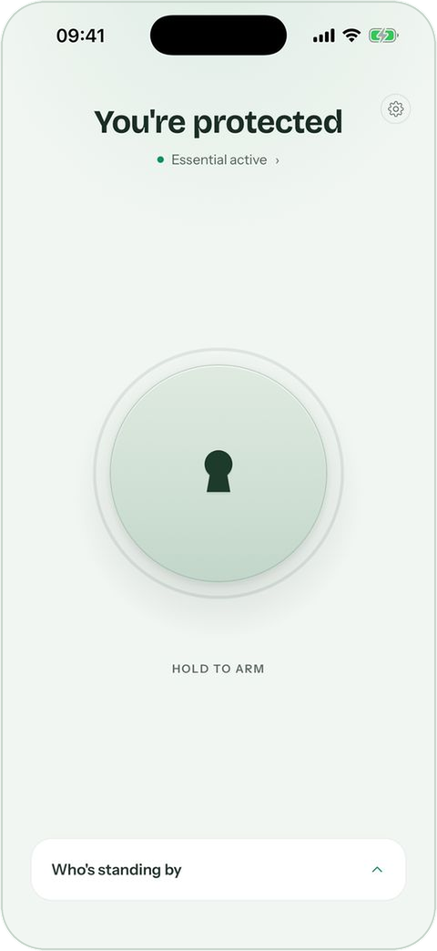  Hold to arm | 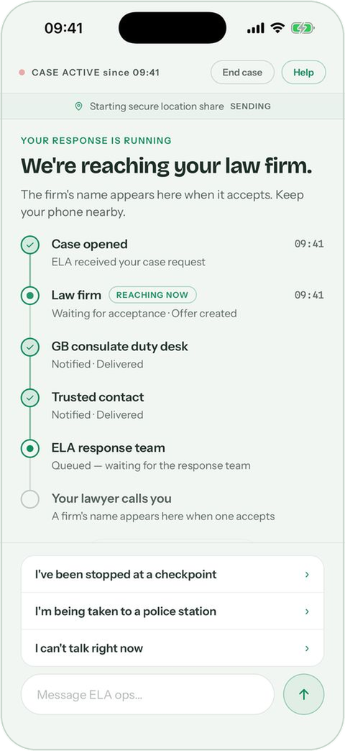  The response, live
  Our 1 October scan found no product in the UAE or the Gulf where one button sends for a lawyer, the consulate and family. Today people pay a firm per case.

How ELA earns  - Membership through the App Store: AED 24.99 a week, 79.99 a month or 749.99 a year. Company seats by contract.  - Insurance add-on: legal fees up to AED 100,000 and bail up to AED 50,000 a claim, for AED 3,000 per adult a year. ELA earns 10% of the premium.  - Legal referral: 10% of legal fees on cases ELA sends; from year three, a panel fee from firms. |  | Routes to market  - Individuals, through social media and legal content creators.  - Employers and SMEs: company-paid seats for resident staff.  - Embassies and consulates: every dispatch alerts the member’s consulate.  - Partners: wellbeing providers, insurers, banks and card issuers.

Year one, monthly model  Members at year end. Revenue and result in AED millions. Our own assumptions, not a forecast. |  | AED 7M  The raise, about USD 1.9M. Base case: profitable from month 9, and cash never falls below AED 5.2M. Cautious case: 14 months of runway. |  | AED 195k+  COO time and cash invested so far, as sweat equity. The CEO’s time is still to be added.
   | Cautious | Base | Upside
  Members | 2,756 | 10,969 | 33,031
  Revenue | 1.6 | 6.2 | 17.1
  Result | (6.0) | (1.8) | 8.0

Team Jonathan Simpson, CEO · Stevan Litobac, COO · Advisors: Shaz Khan, Andrew Trower · TBC: Anna
Contact ela.now

